Margot Cohen
NYC Health + Hospitals/Woodhull
Clinical Rotation
QuadraMed Computerized Patient Record
Oncology Chart Review
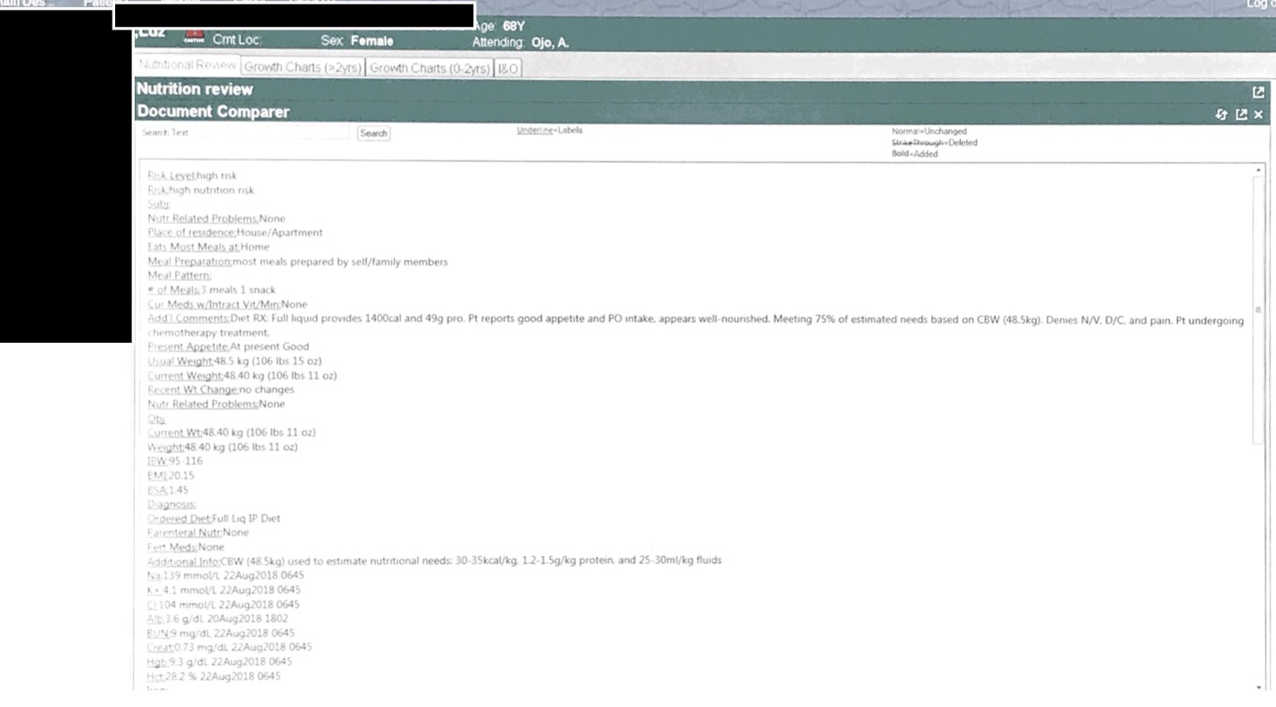

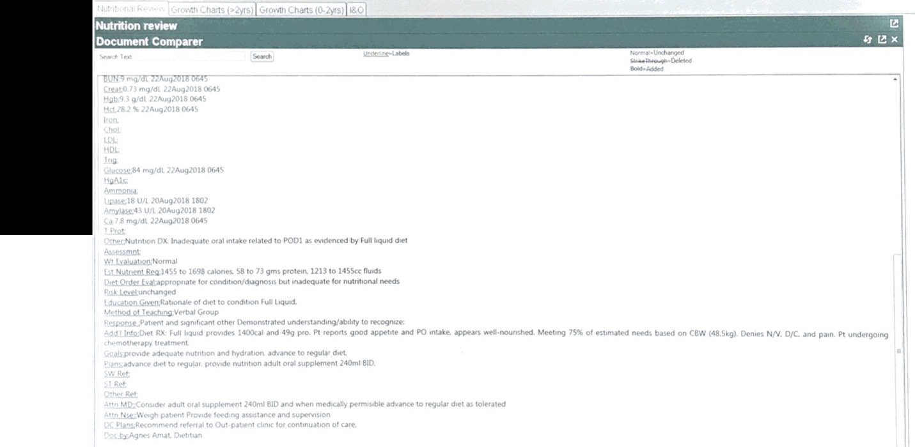

Intern’s Comments:
The patient and family were receptive to the intervention – understood why the patient was on a full liquid diet. I also provided education for increasing intake during chemotherapy, how to season foods/tricks to help with appetite and nausea. The patient and family were very receptive to this – asked a lot of questions and requested written materials to bring home so they would not forget.

Update:
I was unable to determine the success of the nutrition intervention because the patient was discharged before the scheduled follow-up date.

Applies to: CRDN 1.6 Incorporate critical-thinking skills in overall practice. CRDN 2.1 Practice in compliance with current federal regulations and state statutes and rules, as applicable and in accordance with accreditation standards and the Scope of Nutrition and Dietetics Practice and Code of Ethics for the Profession of Nutrition and Dietetics. CRDN 2.2 Demonstrate professional writing skills in preparing professional communications. CRDN 2.11 Show cultural competence/ sensitivity in interactions with clients, colleagues and staff. CRDN 3.1 Perform the Nutrition Care Process and use standardized nutrition language for individuals, groups and populations of differing ages and health status, in a variety of settings. CRDN 3.3 Demonstrate effective communications skills for clinical and customer services in a variety of formats and settings. CRDN 4.10 Analyze risk in nutrition and dietetics practice.

