Margot Cohen
NYC Health + Hospitals/Woodhull
Clinical Rotation
QuadraMed Computerized Patient Record
Nutrition Support Chart Review
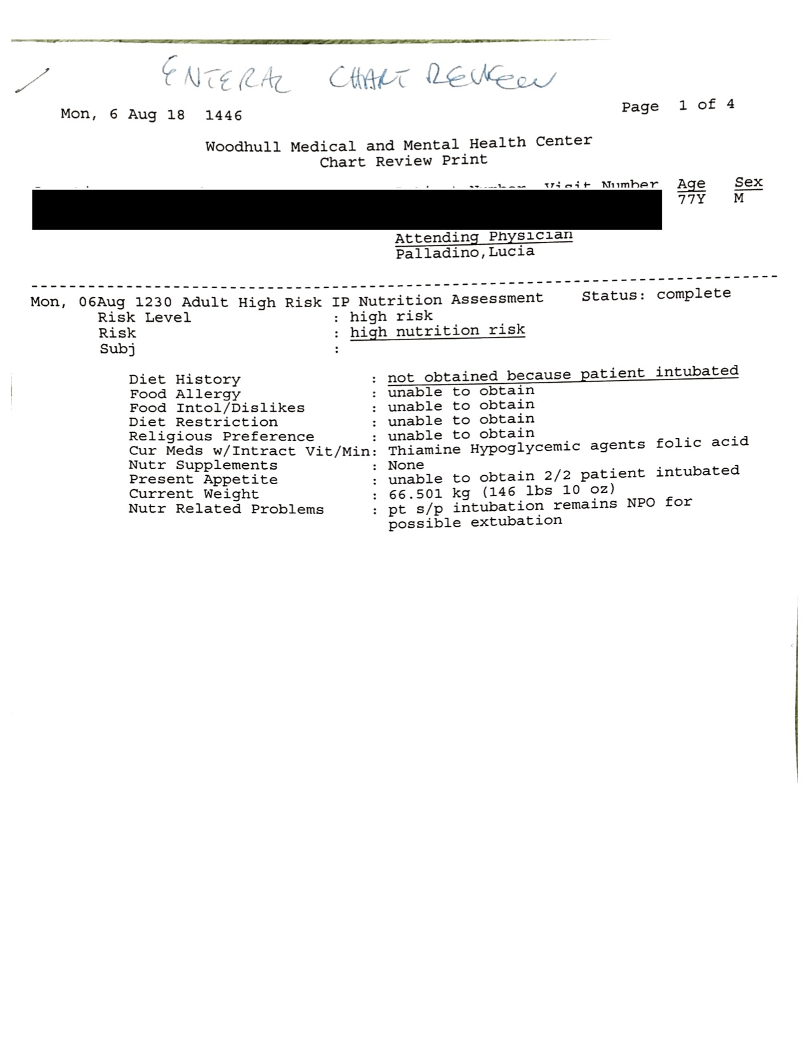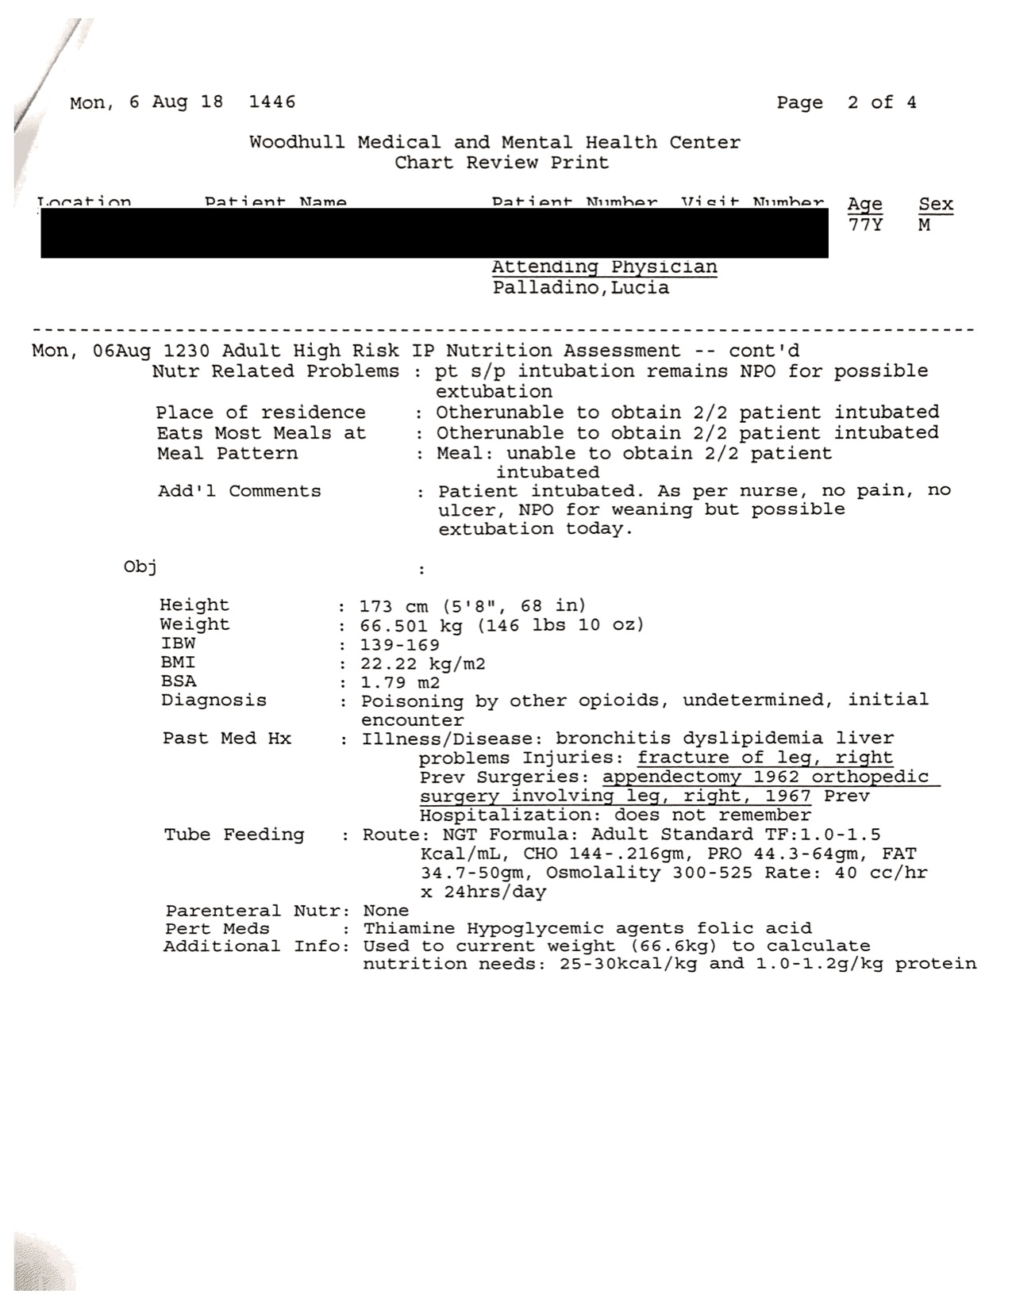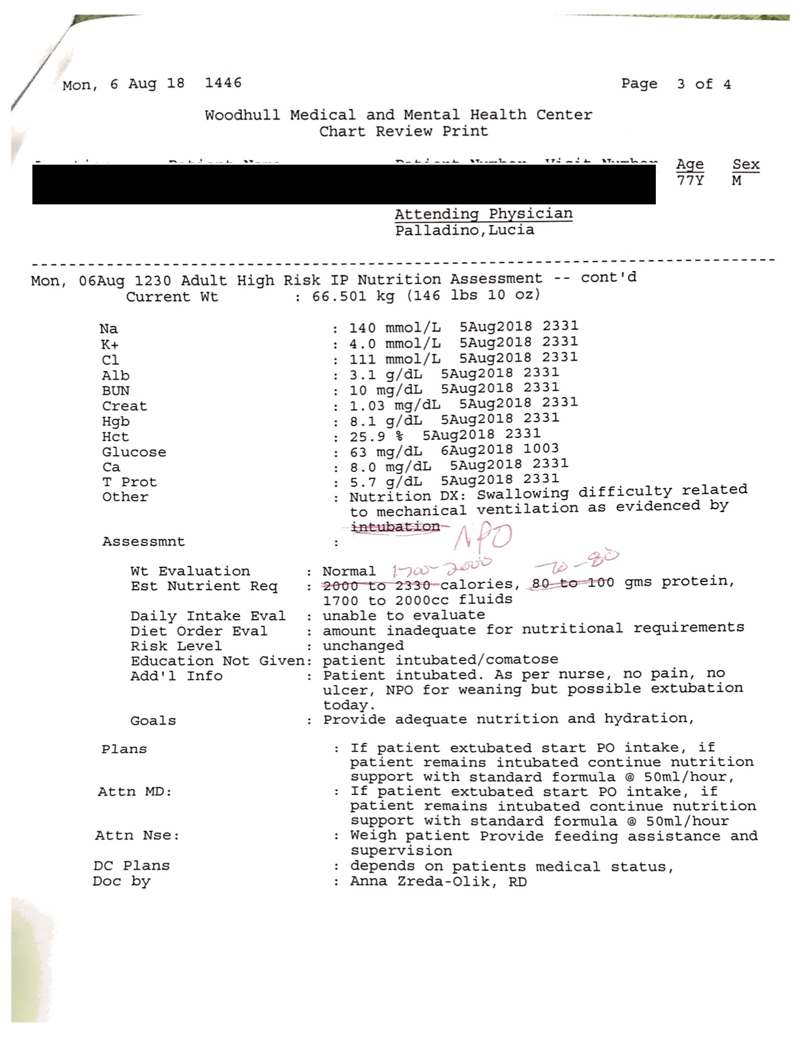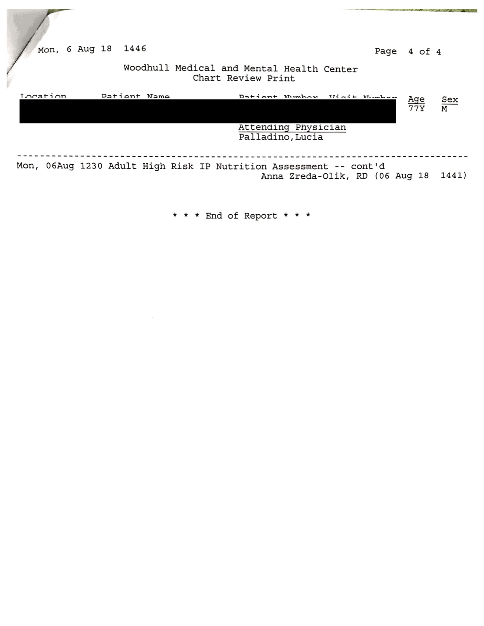

Intern’s Comments:
I cannot assess receptiveness to the nutrition intervention because the patient was intubated, and no family members were present.

Update:
The intervention was successful – I followed up with the nurse and the patient was extubated and tolerated PO intake.

Applies to: CRDN 1.6 Incorporate critical-thinking skills in overall practice. CRDN 2.1 Practice in compliance with current federal regulations and state statutes and rules, as applicable and in accordance with accreditation standards and the Scope of Nutrition and Dietetics Practice and Code of Ethics for the Profession of Nutrition and Dietetics. CRDN 2.2 Demonstrate professional writing skills in preparing professional communications. CRDN 2.11 Show cultural competence/ sensitivity in interactions with clients, colleagues and staff. CRDN 3.1 Perform the Nutrition Care Process and use standardized nutrition language for individuals, groups and populations of differing ages and health status, in a variety of settings. CRDN 3.3 Demonstrate effective communications skills for clinical and customer services in a variety of formats and settings. CRDN 4.10 Analyze risk in nutrition and dietetics practice.

