Margot Cohen
NYC Health + Hospitals/Woodhull
Clinical Rotation
QuadraMed Computerized Patient Record
ADIME Progress Note
HIV Chart Review
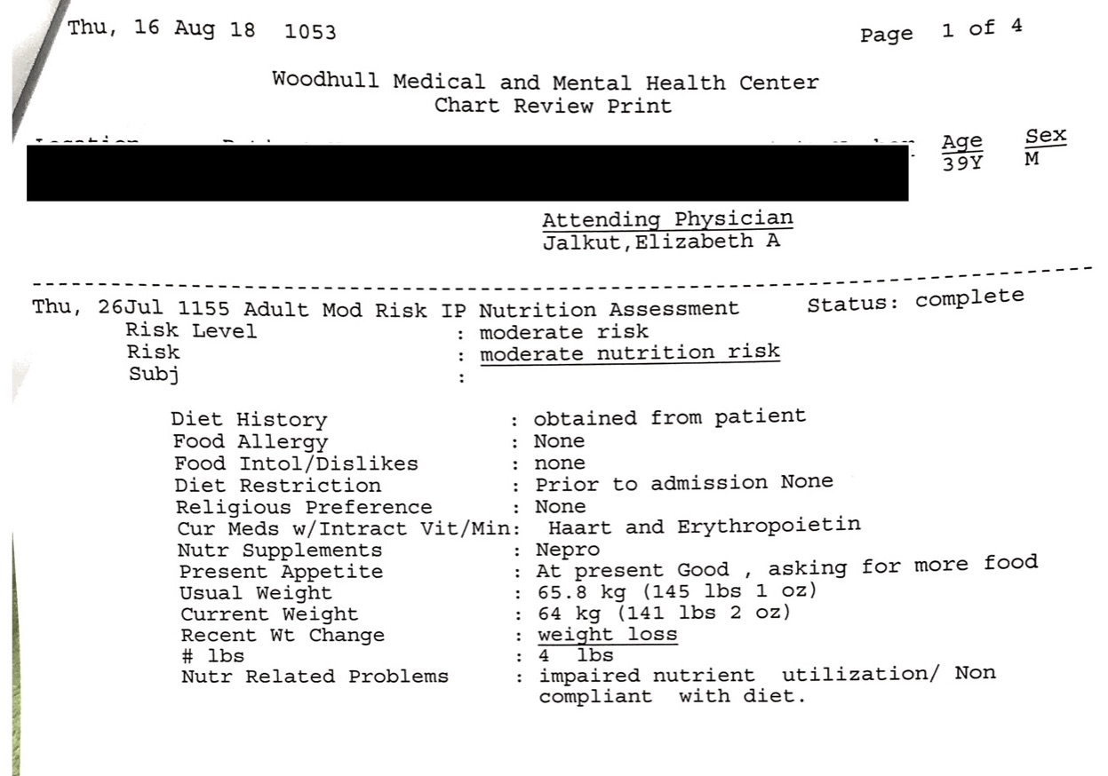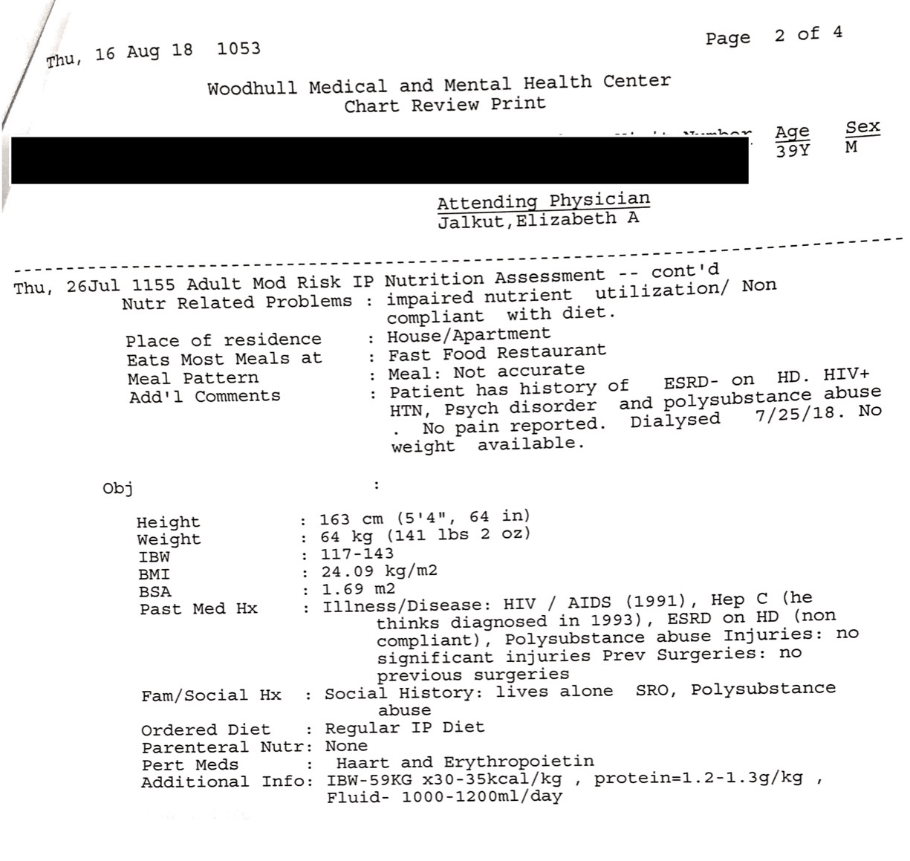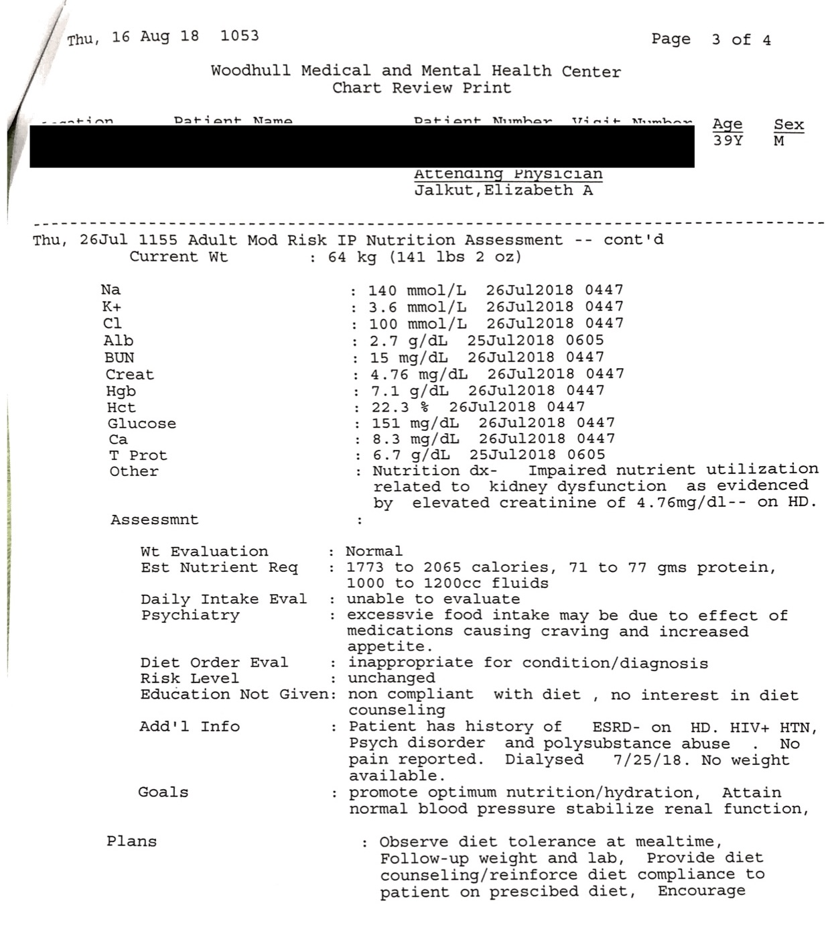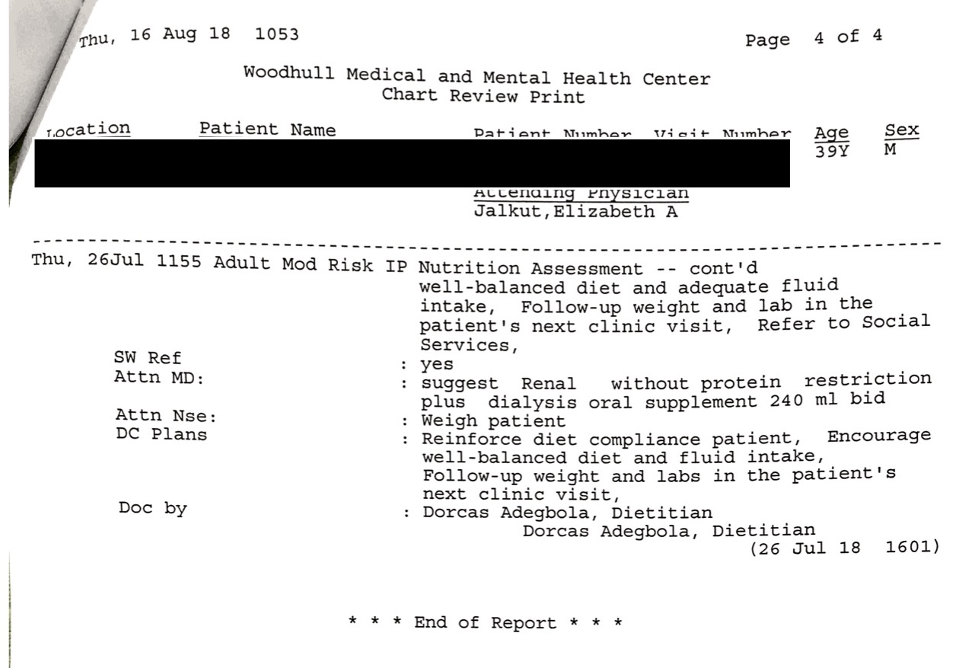
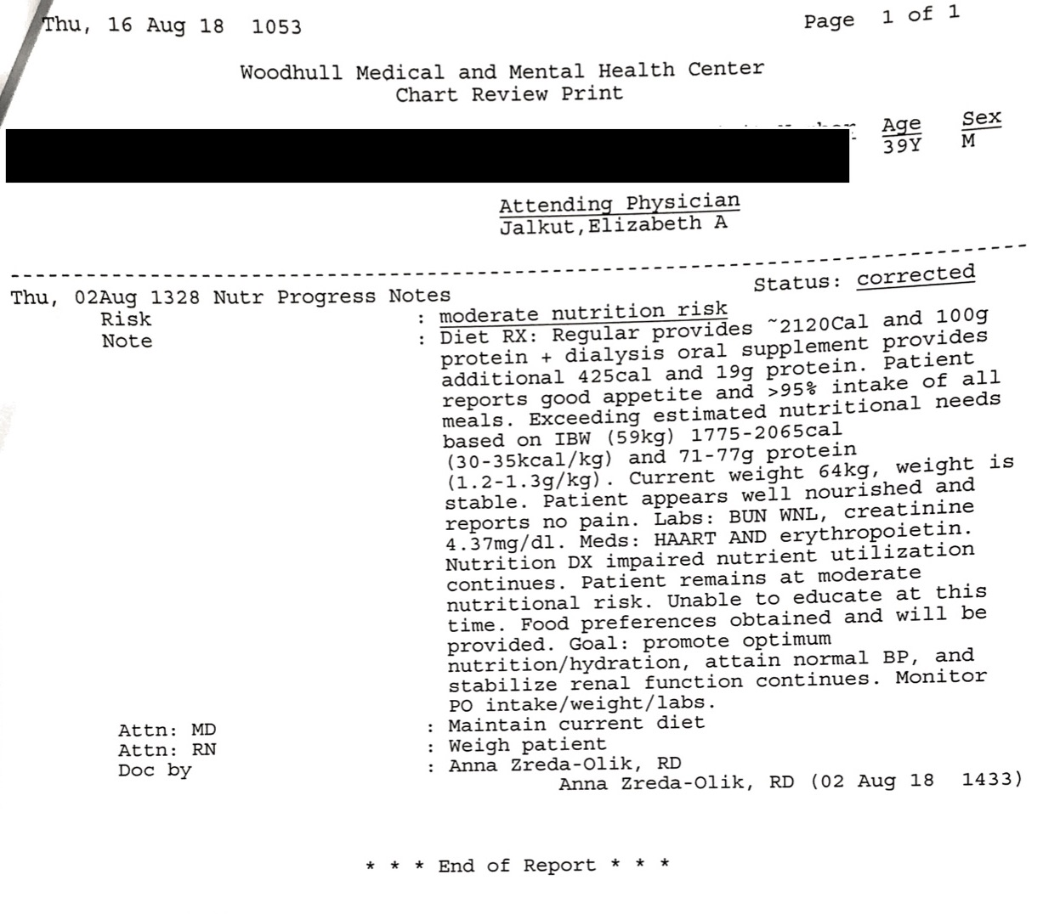
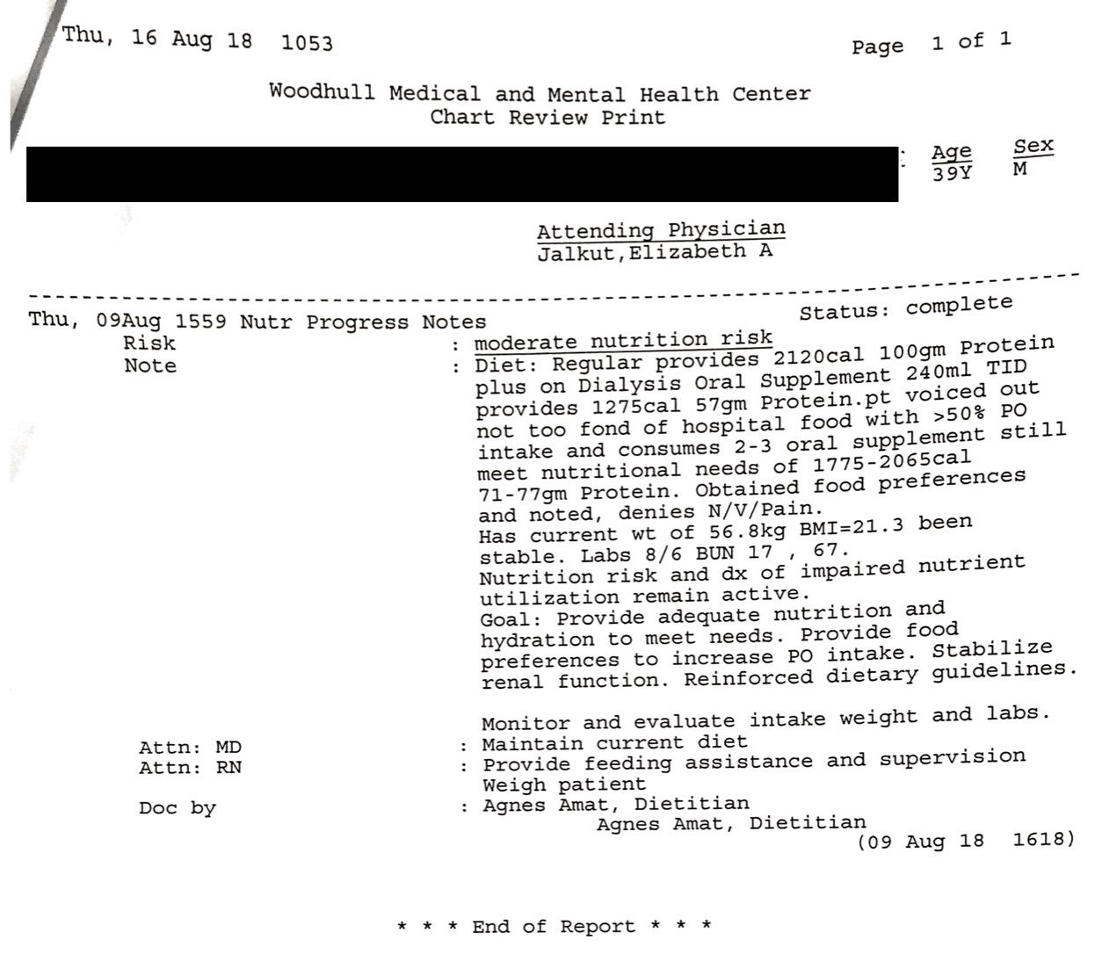
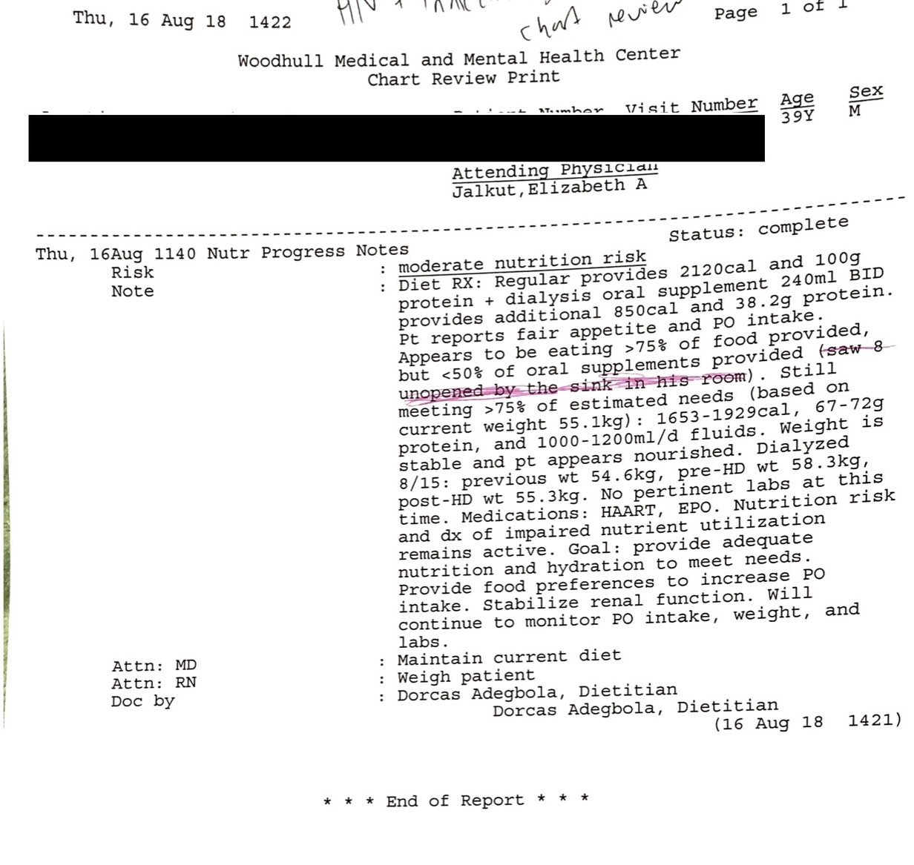
Intern’s Comments: Each time I saw the patient he asked for more food and had specific food preferences. I tried to educate the patient on healthy eating, but he was not ready, he just wanted to talk about his food preferences. I documented his food preferences to ensure he was eating enough.

Update: The intervention was successful because his weight and labs remained stable.

Applies to: CRDN 1.6 Incorporate critical-thinking skills in overall practice. CRDN 2.1 Practice in compliance with current federal regulations and state statutes and rules, as applicable and in accordance with accreditation standards and the Scope of Nutrition and Dietetics Practice and Code of Ethics for the Profession of Nutrition and Dietetics. CRDN 2.2 Demonstrate professional writing skills in preparing professional communications. CRDN 2.11 Show cultural competence/ sensitivity in interactions with clients, colleagues and staff. CRDN 3.1 Perform the Nutrition Care Process and use standardized nutrition language for individuals, groups and populations of differing ages and health status, in a variety of settings. CRDN 3.3 Demonstrate effective communications skills for clinical and customer services in a variety of formats and settings. CRDN 4.10 Analyze risk in nutrition and dietetics practice.

