Margot Cohen
NYC Health + Hospitals/Woodhull
Clinical Rotation
QuadraMed Computerized Patient Record
GI Disorders Chart Review

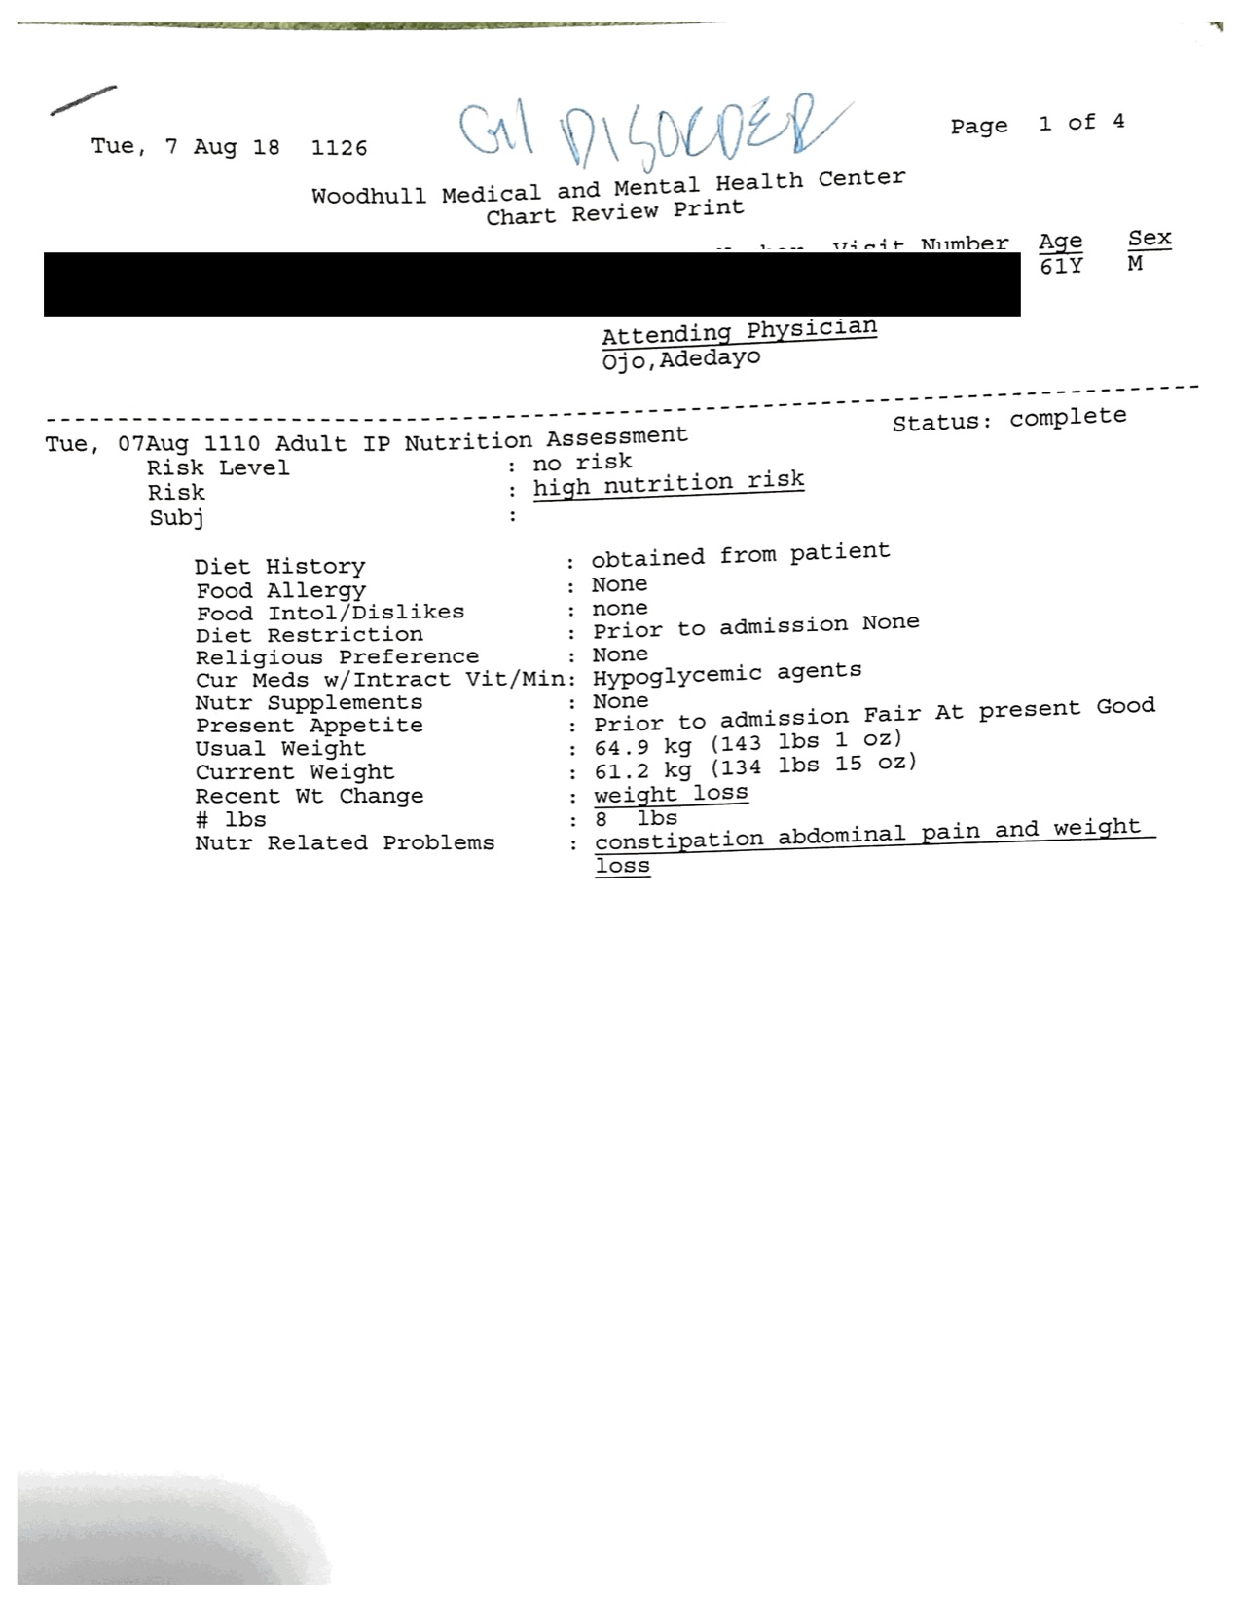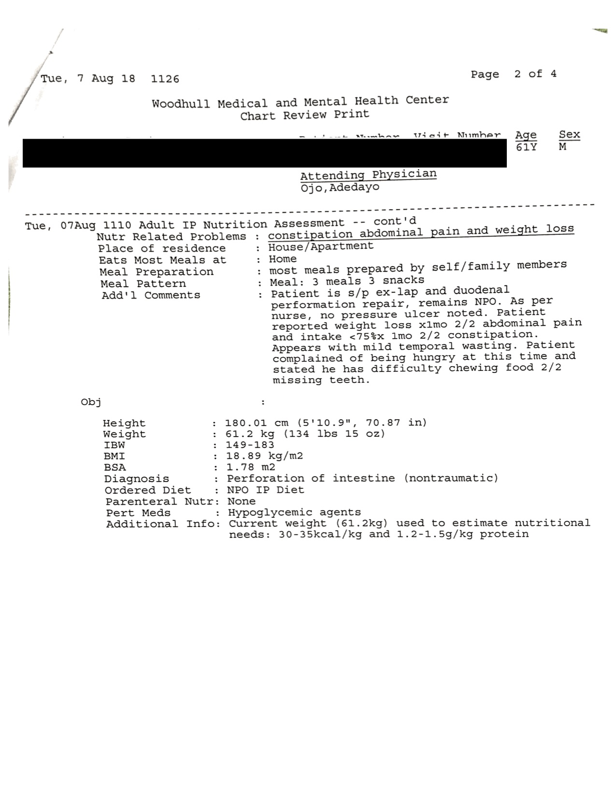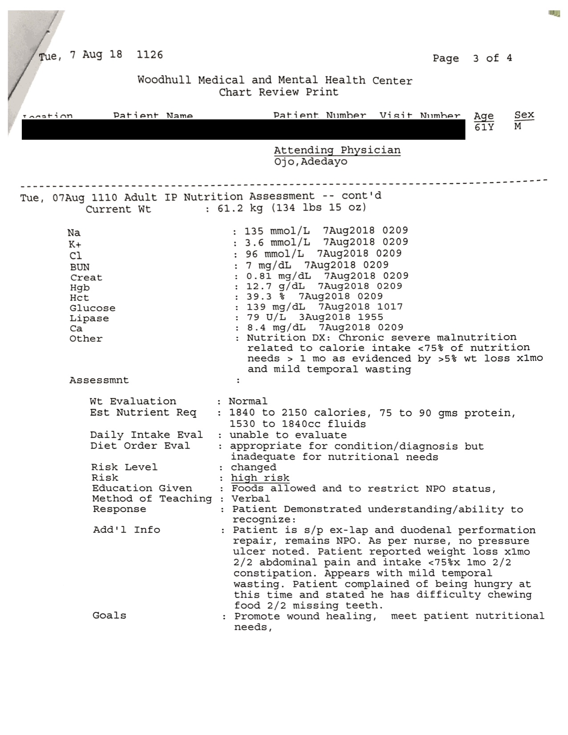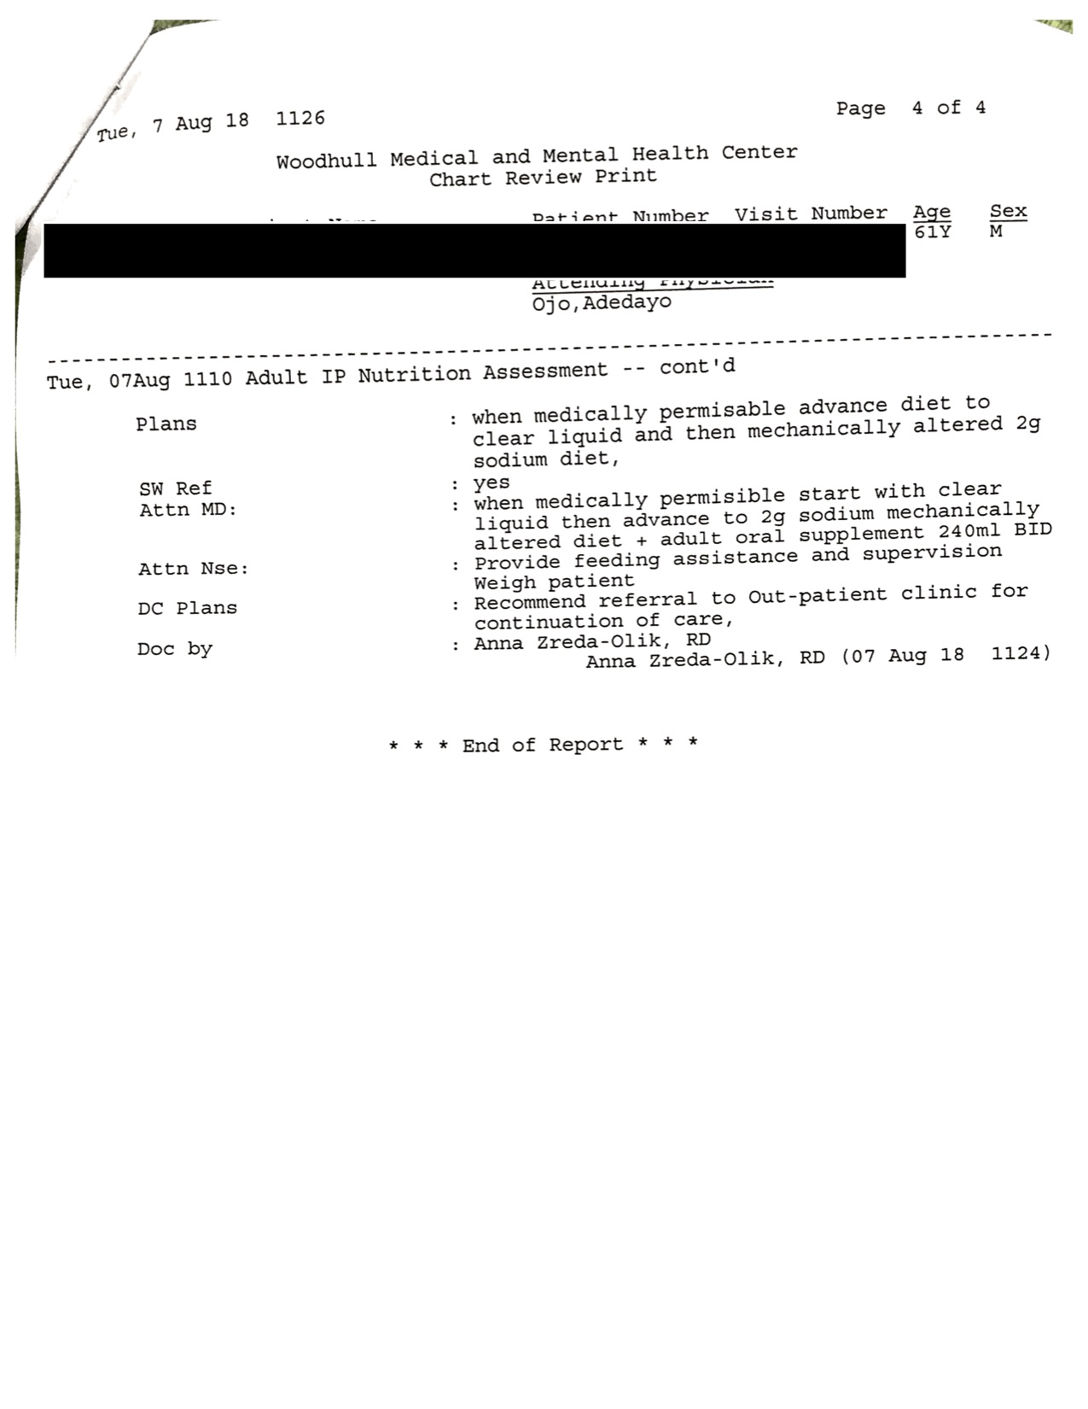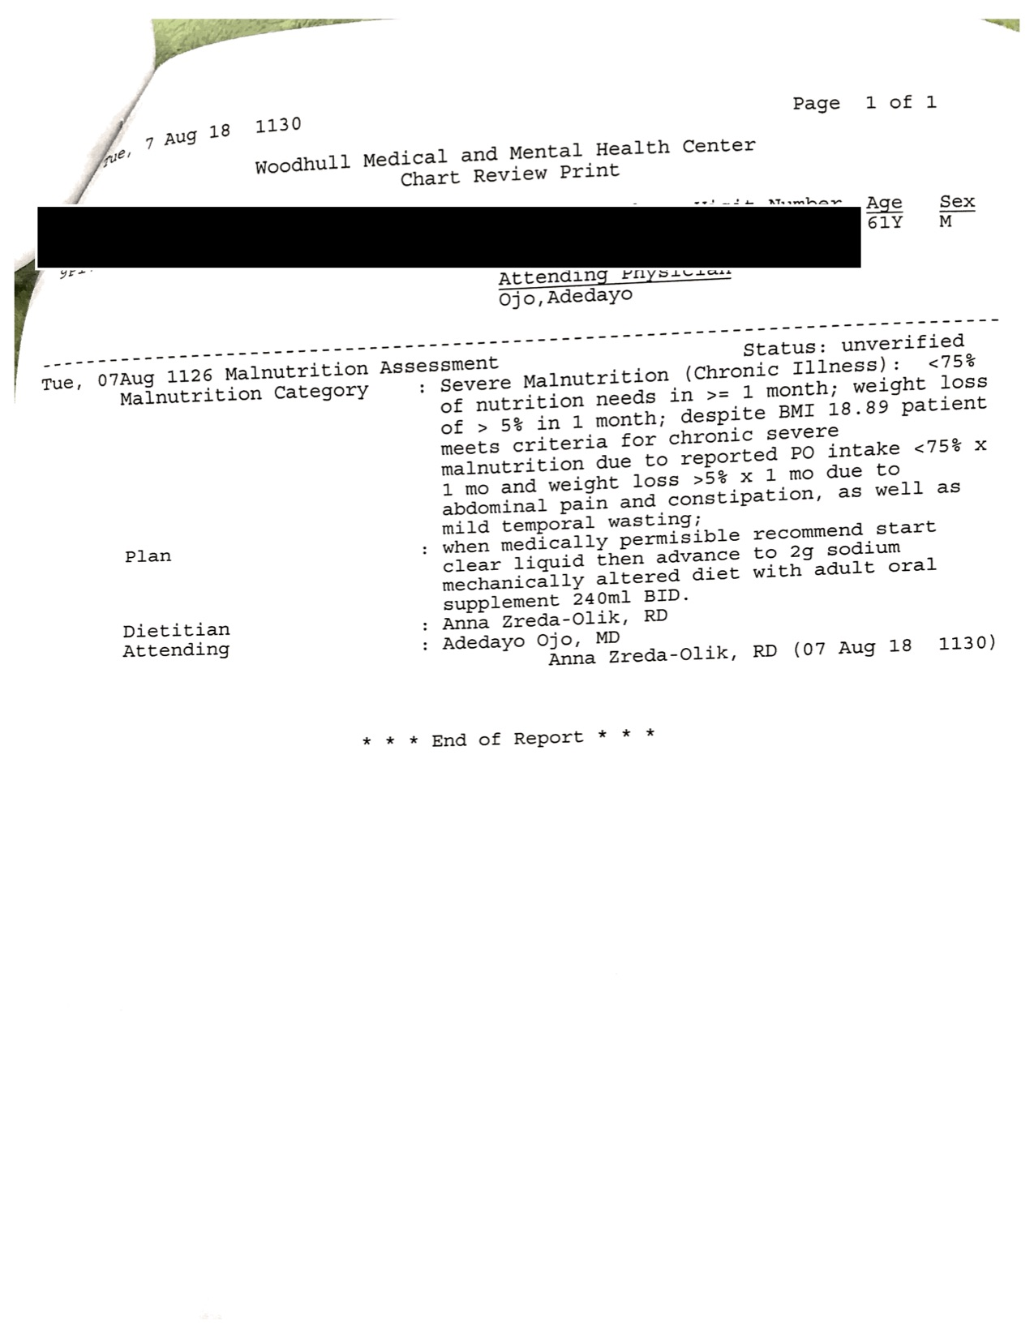

Intern’s Comments:
I explained to the patient why he was NPO and he verbalized understanding but complained that he was hungry and wanted to eat soon.

Update:
The doctor advanced the patient to a clear liquid diet once it was medically permissible and when it was clear he was tolerating that, he was advanced to a mechanically altered 2g sodium diet plus with 2 adult oral supplements daily.

Applies to: CRDN 1.6 Incorporate critical-thinking skills in overall practice. CRDN 2.1 Practice in compliance with current federal regulations and state statutes and rules, as applicable and in accordance with accreditation standards and the Scope of Nutrition and Dietetics Practice and Code of Ethics for the Profession of Nutrition and Dietetics. CRDN 2.2 Demonstrate professional writing skills in preparing professional communications. CRDN 2.11 Show cultural competence/ sensitivity in interactions with clients, colleagues and staff. CRDN 3.1 Perform the Nutrition Care Process and use standardized nutrition language for individuals, groups and populations of differing ages and health status, in a variety of settings. CRDN 3.3 Demonstrate effective communications skills for clinical and customer services in a variety of formats and settings. CRDN 4.10 Analyze risk in nutrition and dietetics practice.

